CURRICULUM VITAE

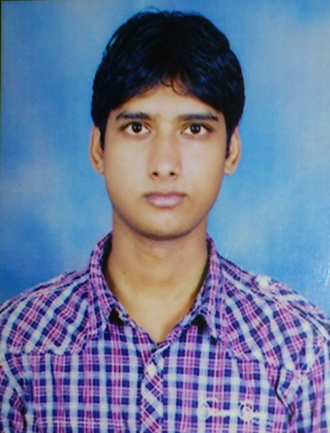
FULL NAME: - Mr.Naman Kumar Johri

PRESENT ADDRESS:-

Flat-G1,House no 7, Block A, Khurd no 119,
Rajpur Khurd, Chattarpur - 110074

EMAIL:-namanjauhari@yahoo.com

PHONE NO: - 09910776330
05624057617

ABOUT ME

I am very ambitious person. Who likes to complete his work with perfection from start to finish delivering the perfect result.

EXTRA QUALIFICATION

I have good knowledge in Computer applications, Internet, Software. Also worked as a software consultant.

PROFESSIONAL QUALIFICATION

Name of Company | Designation | Period
Convergys India , Gurgaon | Technical Support Officer | November 11th 2013 to April 3rd 2015
Hilton, Doubletree by Hilton, Delhi | Guest Service Agent | October 15th 2012 to October 10th 2013
Jaypee Palace Hotel , Agra | Team Associate | July 1st 2011 to September 30th 2012

EDUCATIONAL QUALIFICATION

Name & location of Institute | Board / University | Qualification | Year | Result
Heritage Institute of Hotel & Tourism, Agra | PTU | BSCHMCTT | 2007-2010 | Passed
St Conrad’s Inter College, Agra | I.C.S.E. Board | Inter Mediate | 2007 | Passed
St Conrad’s Inter College, Agra | I.C.S.E. Board | High School | 2005 | Passed

TRAINING EXPOSURE

Training | Name & Address of Hotel | DOJ / DOL | Responsibilities / Achievements
Training | Park Plaza Sylverton (A Sarovar Hotel), Mussoorie | 20th Apr, 2009 to 20th Sep 2009 | Worked in all Four major departments of the Hotel

PERSONAL INFORMATION

PERMANANT ADDRESS:- 6C/22, Lane No -3 , Azad Nagar, Khandari , Agra-282002
________________________________________________________________________________
CITY: - Agra STATE: - U.P. TELEPHONE NO:- 0562-4057617

DATE OF BIRTH :  19/07/1990 | NATOINALITY :- Indian  MOTHER TONGUE:- Hindi | MARITAL STATUS :  Single Married

FAMILY DETAILS

MEMBER | NAME | QUALIFICATION | OCCUPATION
Father | Late. M. C. Johri | M.Com ,LLB | DySP of Police
Mother | SmtShashibala | Intermediate | Housewife

LANGUAGES

FOREGIN | SPEAK |  |  | WRITE |  |  | READ |  |  | TRANSLATE
 | SLIGHT | FAIR | FLUENT | SLIGHT | FAIR | FLUENT | SLIGHT | FAIR | FLUENT | SLIGHT | FAIR | FLUENT
1. French | YES |  |  | YES |  |  | YES |  |  | YES
INDIAN | SPEAK |  |  | WRITE |  |  | READ |  |  | TRANSLATE
 | SLIGHT | FAIR | FLUENT | SLIGHT | FAIR | FLUENT | SLIGHT | FAIR | FLUENT | SLIGHT | FAIR | FLUENT
1. English |  |  | YES |  |  | YES |  |  | YES |  |  | YES
2. Hindi |  |  | YES |  |  | YES |  |  | YES |  |  | YES

HOBBIES

- Watching Hollywood Movies
- Playing Piano.
- Listening Songs
- Surfing Internet

Signature Date
Naman Kumar Johri 23rd September, 2015

